|  |  |
| --- | --- |
| **Soal Praktikum**  *Practicum Case* | LogoBINUS-University |
| T0016  Algorithm and Programming |
| **Teknik Informatika**  *Computer Science* | **O1-T0016-SU01** |
| **Periode Berlaku** Semester Ganjil 2014/2015  ***Valid on*** *Odd Semester Year 2014/2015* | **Revisi 00**  *Revision 00* |

## Learning Outcomes

* Write a program in C language in problem solving

## Topic

* Session 09 – File

## Sub Topics

* Read data from file
* Write data to file

## Soal

*Case*

You are a programmer of a software house. You are asked by a client to create a program to record the average score of Dota Game. Here are the descripstions of the program:

* The first time the program starts, the program will read the file “**soal09.txt**” and it will display **player name**, **average score** and **number of playing**.
* Program consists of 5 menus:
  1. View Record
  2. Add Player Record
  3. Add New Player
  4. Delete Player
  5. Save and Exit
* If user chooses **View** **Record** (menu ‘**1**’), then:
  + Show all **player name**, **average score**, and **amount of play**.
* If user chooses **Add Player Record** (menu ‘**2**’), then:
  + Ask user to input **player name**. The length of **name** must be **between 1 and 10 characters**.
  + Ask user to input **player score**. The **score** must be between 0 and 100.
  + If the player name does not exist on the list, then show message “**name of** **[player name] not found!**”
  + Update the average score of the player with the following conditions :

**New Average score** = ((**old** **average score** x **numbers of playing**) + **player score**) / (**number of playing** +1)

* If user chooses **Add New Player** (menu ‘**3**’), then:
  + Ask user to input **player name** that want to be added. The length of **name** must be **between 1 and 10 characters**.
  + Updates the list of player with adds the new data of player, then show message “**Data successfully added**”.
* If user chooses **Delete Player** (menu ‘**4**’), then:
  + Ask user to input **player name** that want to be deleted. The length of **name** must be **between 1 and 10 characters**.
  + If the player name does not exist on the list, then show message “**name of** **[player name] not found!**”
  + Delete all data of the player name, then show message ”**[player name]** **successfully** **deleted**”.
* If user chooses **Save and Exit** (menu ‘**5**’), then:
  + Save player list on file ”**soal09.txt**”.
  + Program ends.

**Please run the EXE file to see the sample program.**

**Print Screen of Main Program**

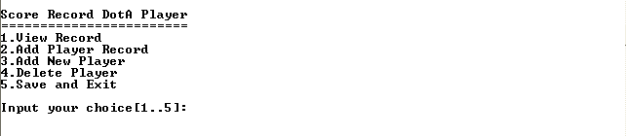

**Print Screen of View Record (Menu ‘1’)**

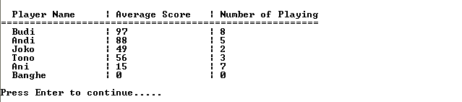

**Print Screen of Add Player Record (Menu ‘2’)**

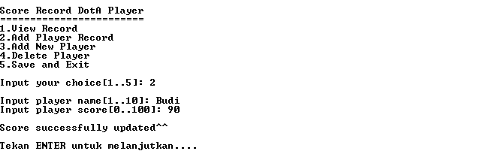

**Print Screen of Add New Player (Menu ‘3’)**

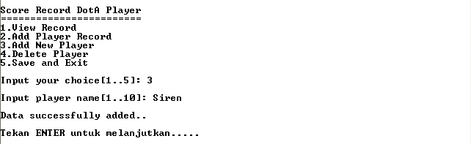

**Print Screen of Delete Player (Menu ‘4’)**

